Report for Vendors Performance Analysis

- Exploratory Data Analysis Insights
 | count | mean | std | 50% | 75% | max
VendorNumber | 197,104.00 | 9,780.82 | 16,901.34 | 7,153.00 | 9,552.00 | 201,359.00
Brand | 197,104.00 | 17,489.50 | 13,096.95 | 17,065.00 | 25,201.00 | 90,631.00
TotalPurchaseQuantity | 197,104.00 | 4,285.07 | 12,945.96 | 755.00 | 3,295.00 | 337,660.00
TotalPurchaseDollars | 197,104.00 | 41,112.80 | 144,374.97 | 8,593.64 | 33,138.63 | 3,811,252.00
PurchasePrice | 197,104.00 | 18.40 | 53.80 | 10.27 | 18.06 | 5,681.81
ActualPrice | 197,104.00 | 27.14 | 74.07 | 15.99 | 25.99 | 7,499.99
Volume | 197,104.00 | 854.06 | 604.07 | 750.00 | 750.00 | 20,000.00
TotalSalesQuantity | 197,104.00 | 333.88 | 1,048.05 | 55.00 | 245.00 | 30,059.00
TotalSalesDollars | 197,104.00 | 4,582.56 | 16,091.50 | 959.40 | 3,714.62 | 660,395.90
TotalSalesPrice | 197,104.00 | 2,038.96 | 4,074.10 | 543.66 | 2,159.73 | 61,470.92
TotalExciseTax | 197,104.00 | 192.49 | 1,065.95 | 9.73 | 63.53 | 44,795.36
FreightCost | 197,104.00 | 65,347.89 | 62,424.22 | 55,551.82 | 89,286.27 | 257,032.10
GrossProfit | 197,104.00 | -36,528.81 | 129,396.96 | -7,523.50 | -1,192.32 | 12,515.16
ProfitMargin | 197,104.00 | -1,635.56 | 20,446.24 | -769.52 | -481.57 | 99.18
StockTurnover | 197,104.00 | 0.19 | 0.89 | 0.08 | 0.12 | 95.40
SalesPurchaseRatio | 197,104.00 | 0.27 | 1.25 | 0.11 | 0.17 | 122.66
Summary Statistics:
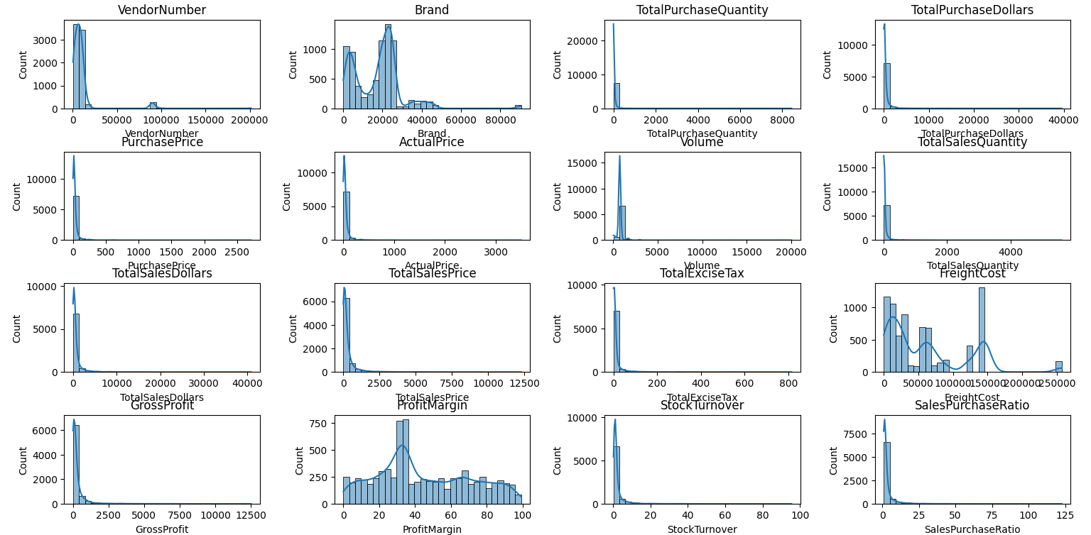
Histrogram Plot:

- NEGATIVE AND ZERO VALUES
✓ Gross Profit: Minimum value is -52,002.78, indicating losses. This means some products or transactions may be selling at a loss due to high costs or discounting below the purchase price.

✓ Profit Margin: Minimum value is -∞ (negative infinity), which suggests cases where revenue is zero or lower than the cost. This typically happens when items are given away for free or returned.
✓ Total Sales Quantity & Sales Dollar: Minimum values are zero, meaning some products were purchased but never sold. These could be slow-moving or obsolete stock items.

- OUTLIERS INDICATED BY HIGH STANDARD DEVIATION
✓ Purchase Price & Actual Price: Maximum values (5,681.81 and 7,499.99) are significantly higher than the mean values (24.39 and 35.64), indicating premium or high-value product categories.

✓ Freight Cost: Huge variation from 0.09 to 257,032.07 suggests logistical inefficiencies, bulk shipments, or exceptional transportation charges.

✓ Stock Turnover: Ranges from 0 to 274.5, implying that some products sell extremely fast while others remain in stock indefinitely. Values greater than 1 indicate that the sold quantity for a product exceeds the purchased quantity — possibly fulfilled using older stock.
Data Filtering:
✓ Only records where Gross Profit is greater than 0 are included — meaning only profitable transactions are considered.
✓ Only records where Profit Margin is greater than 0 are selected — ensuring that the dataset contains items generating positive returns.
✓ Only records where Total Sales Quantity is greater than 0 are kept —so the analysis focuses only on products that have actually been sold.
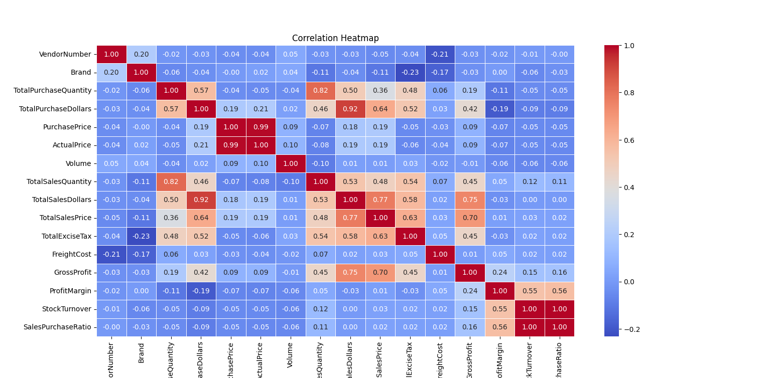
Correlation Plot:

STRONG POSITIVE RELATIONSHIPS
✓ Actual Price and Purchase Price show an extremely strong correlation (~0.99), indicating that selling price closely follows purchase cost.
✓ Total Purchase Dollars and Total Sales Dollars have a strong correlation (~0.92), meaning higher purchase investment leads to higher sales revenue.
✓ Total Purchase Quantity and Total Sales Quantity are highly correlated (~0.82), suggesting products purchased in larger quantities are also sold more.

- Research Questions & Key Findings

1.Brands for Promotional or Pricing Adjustment:
Brands with Low Sales but High Profit Margin
ID | Description | TotalSalesDollars | ProfitMargin
1322 | Santa Rita Organic Svgn Bl | 19.98 | 66.4665
568 | Debauchery Pnt Nr | 23.16 | 65.9758
518 | Concannon Glen Ellen Wh Zin | 31.90 | 64.6630
546 | Crown Royal Apple | 55.72 | 58.3752
1057 | Merry Irish Cream Liqueur | 71.94 | 73.5335
1541 | Tracia Syrah | 89.88 | 68.5551
711 | Georgi Watermelon Vodka | 119.88 | 60.6106
614 | Dr McGillicuddy's Apple Pie | 131.32 | 58.3386
1196 | Pinnacle Cake Vodka | 132.86 | 77.6908
1235 | Promesses de France CdRhone | 143.82 | 92.3376
1490 | The Club Mudslide | 147.26 | 59.0434
493 | Circadia Cab Svgn Napa Vly | 149.98 | 68.0357
1514 | Three Olives Grape Vodka | 170.28 | 69.8227
1314 | Salmon & Trout Bordeaux Blnc | 179.60 | 66.9265
796 | Herzog Kosher Wh Znfdl | 195.72 | 58.2515
1332 | Scagliola Dolcesvago Moscato | 199.60 | 66.6333
981 | Louis Jadot Chmble-Musgny 11 | 199.96 | 65.5131
404 | Ch Pagodes de Cos 10 Brdx | 199.98 | 67.5367
1203 | Pinnacle Orange Whipped | 208.78 | 56.3469
849 | Jadot Fixin 12 | 209.94 | 56.7114
1354 | Seghesio Arneis RRV | 219.80 | 58.8899
1210 | Pinot Evil VDP Beaute Pnt Nr | 239.76 | 59.4595
17 | Absolut Orient Apple Vodka | 239.88 | 55.5478

- This table highlights 22 brands that have a high profit margin but low total sales, showing that these products are profitable but not selling in large quantities.

- These brands may require stronger promotions, targeted marketing, or pricing adjustments to improve their sales performance and increase overall revenue
2.Top Vendors by Sales & Purchase Contribution
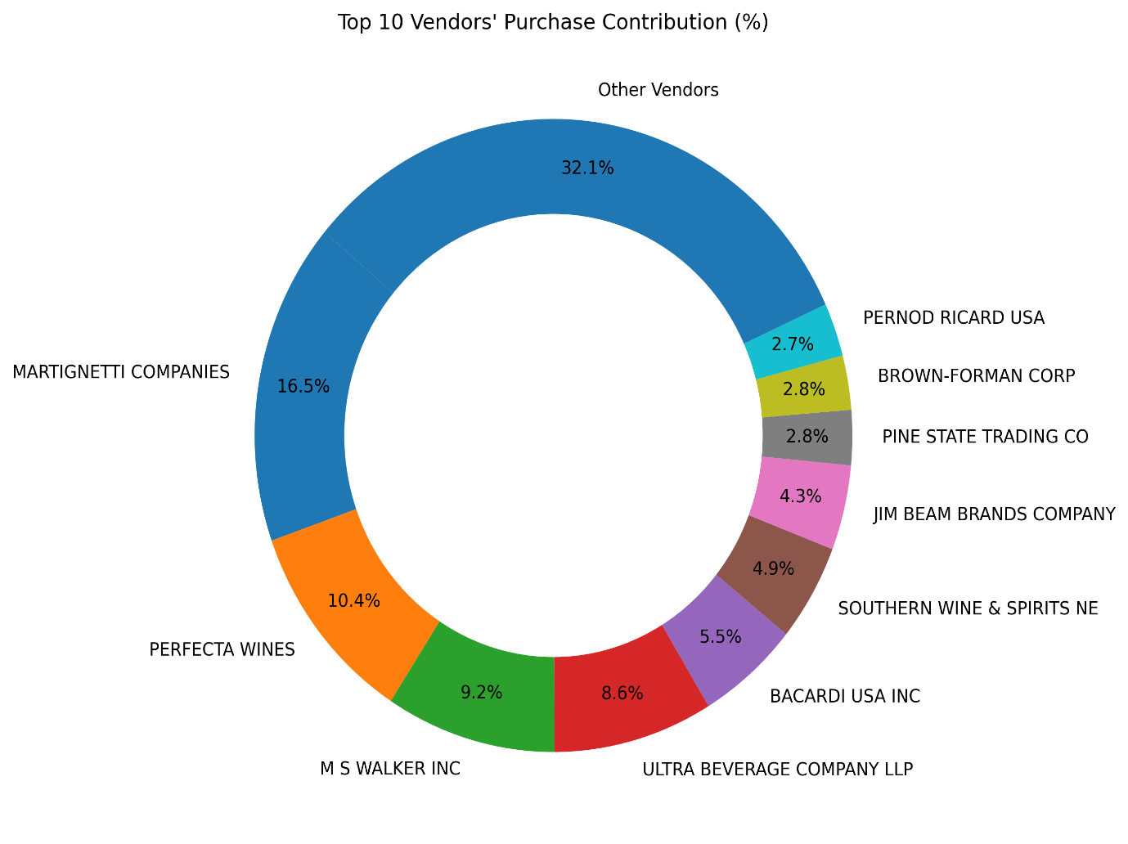
✓ Martignetti Companies is the top contributor with 16.5%, making it the largest individual vendor.
✓ next major contributors are Perfecta Wines (10.4%), M S Walker Inc (9.2%), and Ultra Beverage Company LLP (8.6%).
✓ Smaller vendors collectively dominate the market, with “Other Vendors” contributing 32.1%, indicating a highly fragmented supply base.
✓ The remaining top vendors each contribute between 2% and 6%, showing moderate but distributed purchase activity.
3.Impact of Bulk Purchase on Cost Saving
The Average Unit Purchase Price decreases sharply as order size increases, showing a clear benefit of bulk purchasing:
- Small orders: ₹46.61 per unit
- Medium orders: ₹27.28 per unit
- Large orders: ₹16.84 per unit
This represents a 63% cost reduction from small to large orders.

4. Vendors with Low Inventory Turnover
The vendors listed show very low stock turnover ratios (0.56–0.70), indicating slow-moving inventory. This suggests challenges in demand, pricing, product mix, or vendor performance.
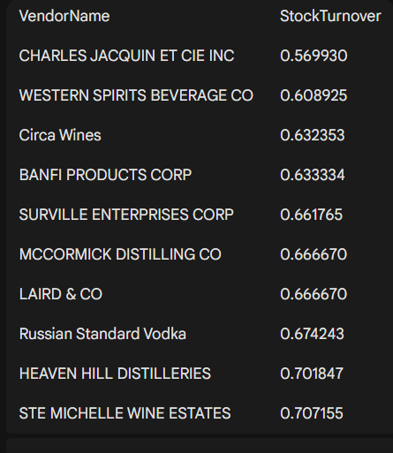

5.Profit Margin Comparison: High Vs Low Performing Vendors:
1 High-Performing Vendors Have Significantly Higher & More Stable Profit Margins
- Top Vendors’ Profit Margin Mean: ~58.66%
- Confidence Interval (95%): 56.16% to 61.16%
- The distribution is tightly clustered → consistent and predictable profitability.
- Their margins generally fall in a high and narrow range, showing strong product demand, premium pricing, and efficient operations.
2 Low-Performing Vendors Show Very Low & Highly Variable Profit Margins
- Low Vendors’ Profit Margin Mean: ~13.41%
- Confidence Interval (95%): 9.48% to 17.33%
- The distribution is spread widely at the lower end → unstable and weak profitability.
- Indicates issues such as:
  - Low demand
  - High discounting
  - Weak pricing power
  - Inefficient cost structure or inventory holding
3 The Profitability Gap Is Substantial
- Top vendors outperform low vendors by ~45 percentage points.
- This huge gap shows that vendor selection and portfolio mix have a major impact on overall margins.
4. Interpretation
- High-performing vendors drive most of the business profitability, justifying stronger partnerships, priority stocking, and better-negotiated terms.
- Low-performing vendors may contribute to:
  - Margin dilution
  - Slow-moving stock
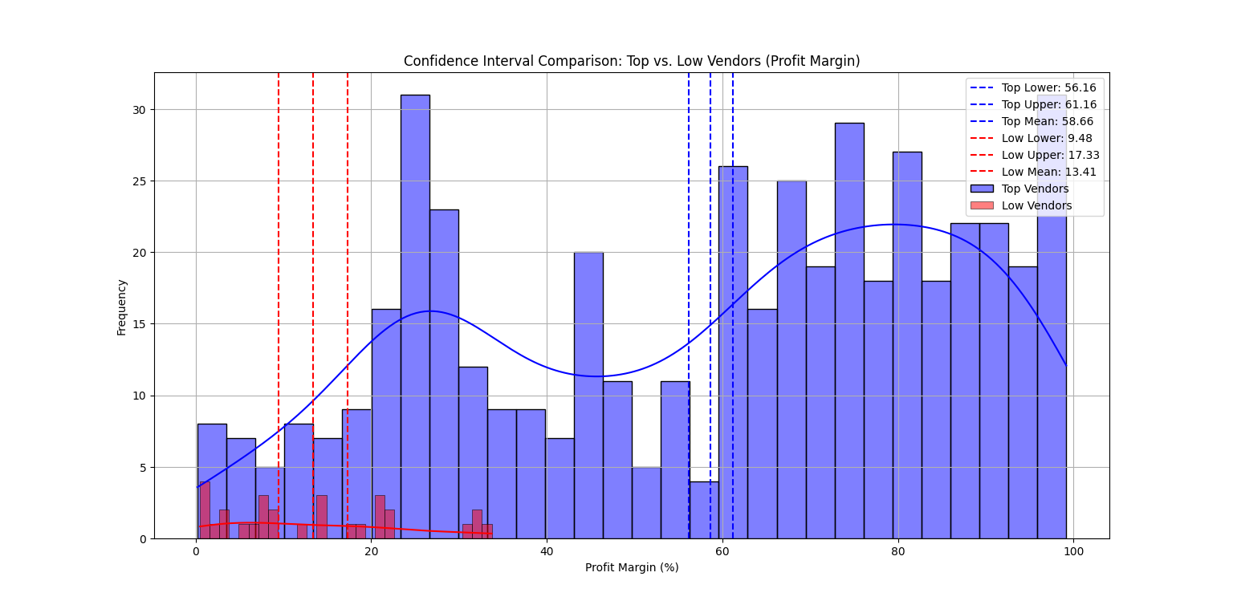
  - Higher holding costs
6.Statistical Validation of Profit Margin Difference:
- H₀ (Null Hypothesis): There is no significant difference in the mean profit margins of top-performing and low-performing vendors.
- H₁ (Alternative Hypothesis): The mean profit margins of top-performing and low-performing vendors are significantly different.

Result: The null hypothesis is not rejected, indicating that top-performing and low-performing vendors do not show a statistically significant difference in profit margins.
Implication: Since margins are similar across both groups, vendor performance should be evaluated using additional metrics such as sales volume, turnover, or demand patterns rather than profit margin alone.

- Final Recommendations
✔ Re-evaluate pricing and promotional strategy for low-sales, high-margin brands to improve their sales performance without reducing profitability.
✔ Strengthen vendor diversification to reduce over-dependence on a few top contributors and minimize supply chain disruptions.
✔ Leverage bulk purchasing more aggressively, as larger order sizes significantly reduce unit costs (up to 63% savings), enabling competitive pricing and better margin control.
✔ Address slow-moving inventory by revising purchase quantities, optimizing product mix, and launching clearance or targeted marketing initiatives.
✔ Improve performance of low-turnover vendors by refining demand forecasting, adjusting purchase frequency, and renegotiating vendor terms.
✔ Evaluate vendor performance using a broader set of metrics such as sales volume, turnover rate, and demand stability—since profit margins alone do not show a statistically significant difference between top and low-performing vendors.
✔ Enhance marketing and distribution strategies for low-performing vendors to boost product visibility and push higher sales volumes without affecting healthy margins.
✔ Focus on top-performing vendors with stable margins for strategic partnerships, better-negotiated agreements, and priority stocking to maintain predictable profitability.

